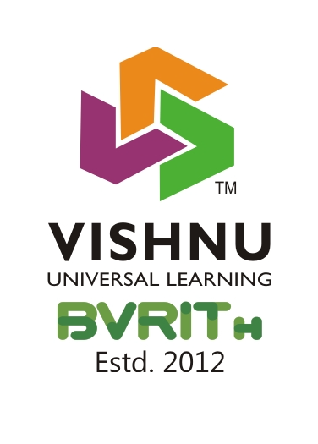
BVRIT HYDERABAD College of Engineering for Women
(UGC Autonomous Institution | Approved by AICTE | Affiliated to JNTUH)
(NAAC Accredited – A Grade | NBA Accredited (EEE, ECE, CSE and IT))
Bachupally, Hyderabad – 500090

Department of Basic Sciences & Humanities (BS&H)

English for Skill Enhancement (2025-26) Odd Semester-1

S. No | Name of the Faculty | English for Skill Enhancement  (I-I) | English Language & Communication Skills Lab (ELCS Lab)  (I-I) | Gender Sensitization Lab (GS Lab)  (II-I) | Advanced Communication Skills Lab (ACS Lab)  (III-I) | Total workload
1 | Dr. S. Faith Manjusha Vijayalatha | CSE-A: 04  CSE-F:04 | CSE-A: 04  CSE-F:04 |  | ECE-A, ECE-B-8 | 24
2 | Dr. S. Ammani Reddy | CSE-C:04  ECE-B:04 | CSE-C:04  ECE-B:04 |  | CSE-A, CSE-B-8 | 24
3 | Dr. Devidutta Das | EEE:04 | EEE:04 | CSE-B:01 | IT-A, IT-B -8 | 17
4 | Ms. Kasturi Sydaiah | ECE-A:04  CSE-D:04 | ECE-A:04  CSE-D:04 | CSE-A:01 | CSE-C - 4 | 21
5 | Ms. G. L. Sirisha | CSE-E:04  CSE-B:04 | CSE-E:04  CSE-B:04 | CSE-E:01 | AIML -4 | 21

Subject I/C HoD Principal

